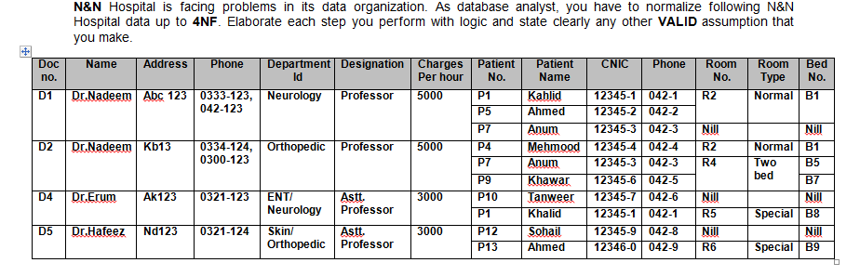

* Normalise the above table upto BCNF.
* Identify and mention the appropriate dependencies in each level of normalization.
* After every normalization level, illustrate the resulting tables with all values
* Elaborate each step clearly and mention any assumption you make to solve the problem.
* Answers can either be submitted as scanned copies of normalization done on paper or as documents where the tables are drawn using tools